**NBTX10442_WEEK3_LAB-B**

Q1.

#include<stdlib.h> // largest number among the given two numbers

#include<stdio.h>

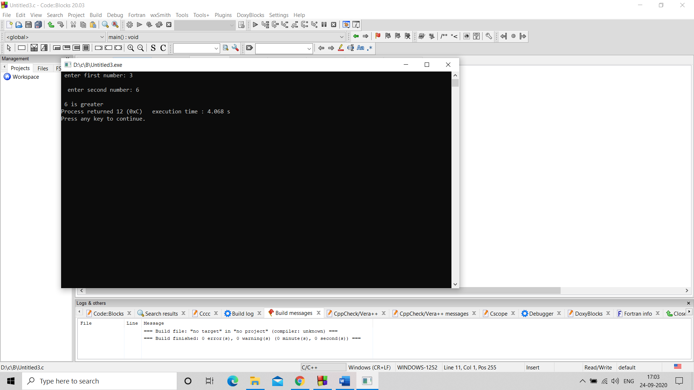void main()

{int b,c;

printf(" enter first number: ");

scanf("%d",&b);

printf(" \n ");

printf(" enter second number: ");

scanf("%d",&c);

printf(" \n ");

if(b>c)

{printf("%d is greater",b);

}

else

{printf("%d is greater",c);

}

}

Q2.

#include<stdlib.h> //number is +ve or ve

#include<stdio.h>

void main()

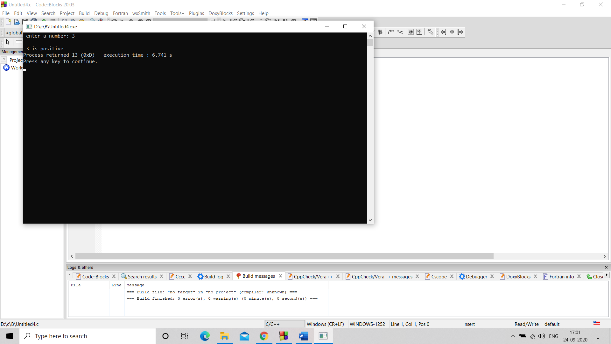{int b;

printf(" enter a number: ");

scanf("%d",&b);

printf(" \n ");

if(b>0)

{printf("%d is positive",b);

}

else if(b<0)

{printf("%d is negative",b);

}

else

printf(" 0 is neither positve nor negative");

}

Q3.

#include<stdlib.h>

#include<stdio.h> // number is even or odd.

void main()

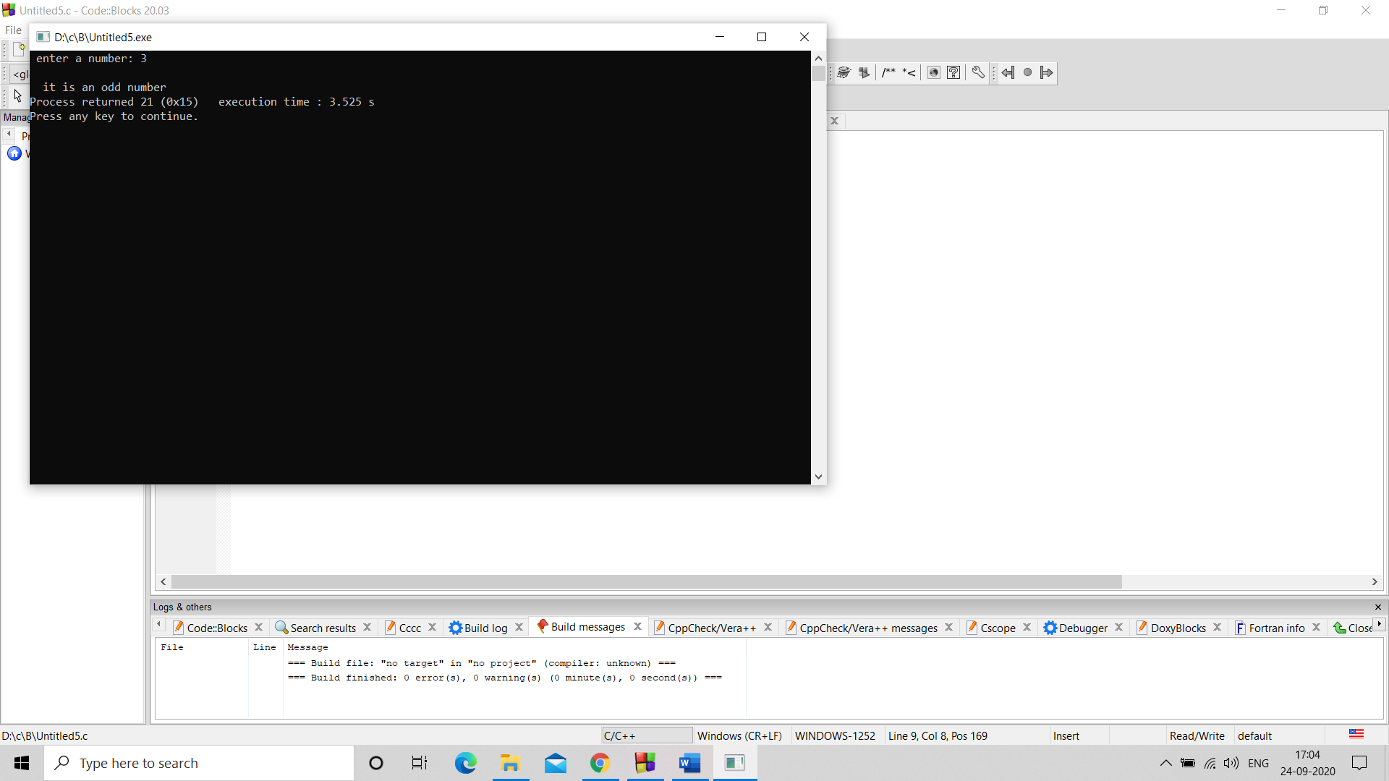{int b;

printf(" enter a number: ");

scanf("%d",&b);

printf(" \n ");

if(b>0)

{if((b%2)==0)

printf(" it is an even number ");

else

printf(" it is an odd number ");

}

else

printf(" this is not a positive number ");

}

Q4.

#include<stdlib.h> // check whether the input character is Vowel or consonant?

#include<stdio.h>

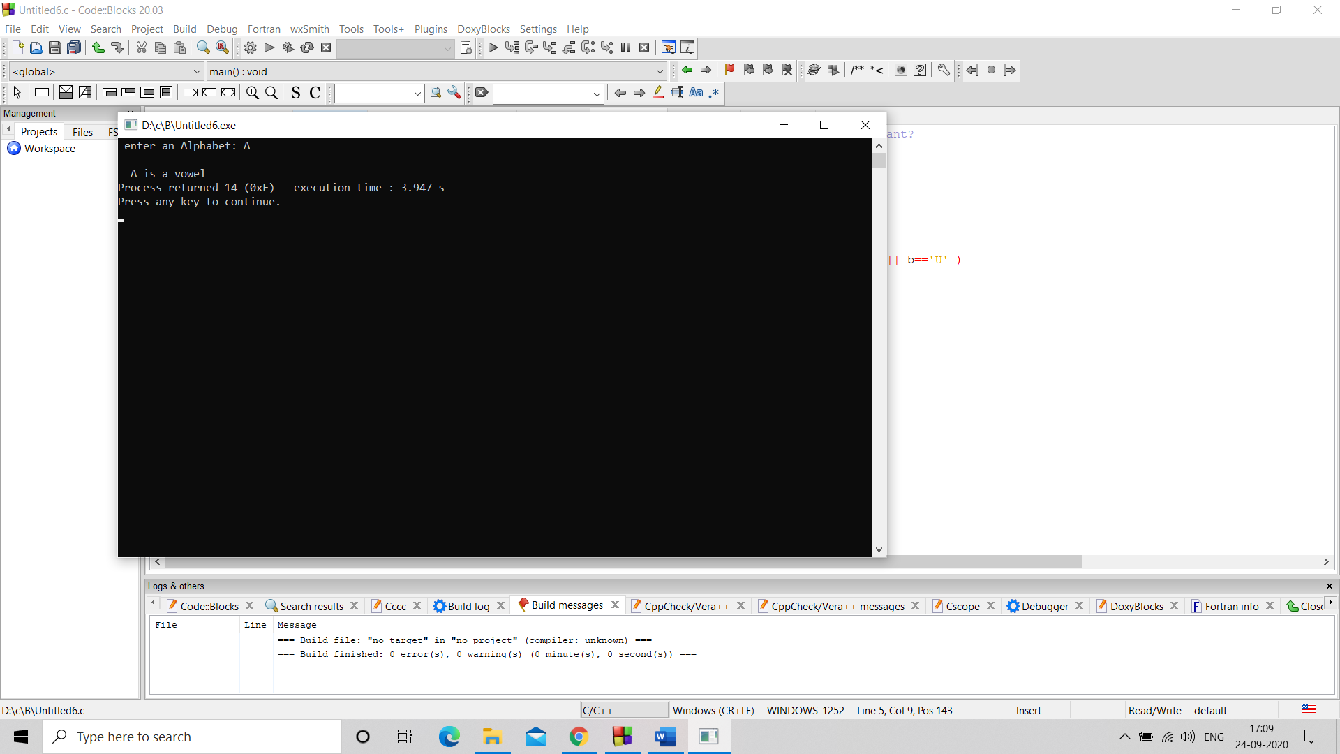

void main()

{char b;

printf(" enter an Alphabet: ");

scanf("%c",&b);

printf(" \n ");

if (b=='a' || b=='e' || b=='i' || b=='o' || b=='u' || b=='A' || b=='E' || b=='I' || b=='O' || b=='U' )

{printf(" %c is a vowel ",b);

}

else if (b>='a' && b<='z' || b>='A' && b<='Z' )

printf(" %c is a consonant ",b);

else

printf(" invalid input ");

}

Q5.

#include<stdlib.h> // voting

#include<stdio.h>

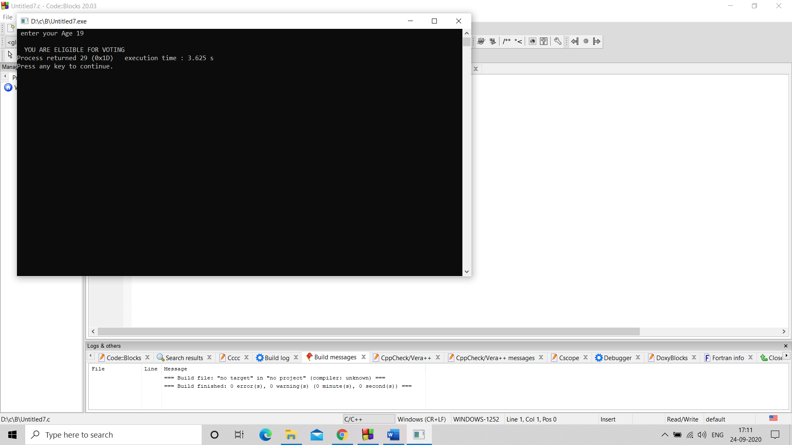void main()

{

int b;

printf(" enter your Age ");

scanf("%d",&b);

printf(" \n ");

if(b<18)

{ printf(" YOU ARE NOT ELIGIBLE FOR VOTING ");

}

else

printf(" YOU ARE ELIGIBLE FOR VOTING ");

}